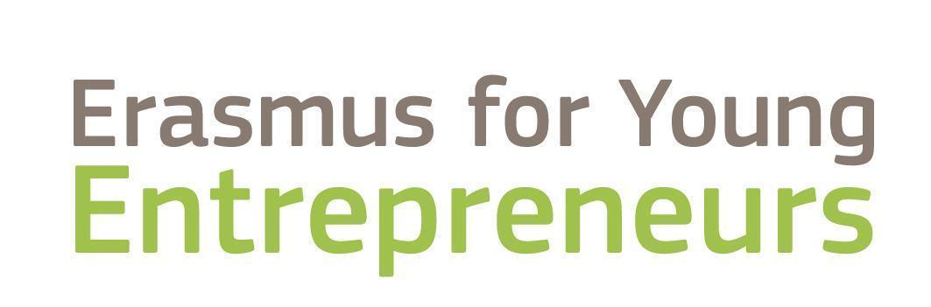

_______________________________________________________________________________________________
EYE4UA

Enabling the green growth of Ukrainian social entrepreneurs

BUSINESS PLAN
4roomsUA

Melnyk Ievgeniia
agnikava@gmail.com
+40746382495

Bulevardul 1 Decembrie 1918, № 59, ap. 13
Targu Mures, Mures, 540061
TABLE OF CONTENTS
EXECUTIVE SUMMARY 3
COMPANY OVERVIEW 4
PROBLEM & SOLUTION 5
THE PROBLEM 5
OUR SOLUTION 5
TARGET MARKET 6
MARKET SIZE & SEGMENTS 6
RISK ANALYSIS………………………………………………………………………………………………………………….7
SWOT ANALYSIS………………………………………….…………………………………………………………………….8
COMPETITION 9
CURRENT ALTERNATIVES TARGET BUYERS ARE USING 9
OUR COMPETITIVE ADVANTAGES 9
PRODUCT OR SERVICE OFFERINGS 10
PRODUCT OR SERVICE 10
MARKETING 11
MARKETING PLAN 11
ORGANIZATION AND MANAGEMENT…………………………….……………………………………………………….12
TIMELINE & METRICS 13
TIMELINE 13
MILESTONES 13
KEY PERFORMANCE METRICS 13
FINANCIAL FORECASTS 15
KEY ASSUMPTIONS 15
ADDITIONAL MATERIAL………………………………….……………………………………………………………………16

EXECUTIVE SUMMARY
4roomsUA is a store and online platform in Romania specializing exclusively in Ukrainian clothing and accessories.
Executive Summary
4roomsUA introduces a pioneering retail and online concept in Romania, the first store dedicated entirely to Ukrainian fashion, craftsmanship, and design. The boutique and its digital platform bring together a curated selection of clothing and accessories that embody both cultural heritage and modern style. The assortment ranges from traditional embroidered garments and symbolic ornaments to contemporary streetwear, limited capsule collections, and premium accessories.

The company’s mission is clear: “4roomsUA is a symbol of cultural dialogue. We combine Ukrainian heritage with European fashion, creating clothing that makes the past relevant and the present meaningful.”

Market Opportunity
Romania’s fashion industry, valued at €6.9 billion in 2023, is projected to grow to €8.5 billion by 2028, with online fashion sales expanding by over 20% annually. Within this thriving market, 4roomsUA positions itself in a distinct and underrepresented niche, the fusion of Ukrainian identity and European fashion sensibility.
The brand targets three key audiences: the Ukrainian diaspora seeking authentic cultural representation, Romanian youth drawn to creative and ethical fashion, and tourists in search of meaningful, story-driven souvenirs. Given that over half of Romanians express strong support for Ukraine, the social context further amplifies the brand’s appeal.
The brand targets three primary customer groups:
- The Ukrainian diaspora in Romania (around 190,000 people), who seek authentic cultural representation in their everyday lives.
- Romanian youth aged 18 - 35 (approx. 2.5 million), drawn to creative and ethical fashion with a strong story.
- Tourists (around half a million annually), who look for meaningful, authentic souvenirs that reflect regional artistry and culture.
With over half of Romanians expressing support for Ukraine, the social and cultural environment is highly favorable for a business that celebrates Ukrainian identity through creativity and design.

Competition:
- International chains (Zara, H&M, Bershka): mass market, but no uniqueness;
- Local boutiques: personalized service, but no Ukrainian brands;
- Online platforms (Zalando, ASOS): more expensive and slower delivery.
4roomsUA fills this gap with a distinctive offering: Ukrainian fashion + cultural identity + accessible pricing, making it both meaningful and competitive.
4roomsUA differentiates itself from competitors such as Zara, H&M, and local boutiques through a distinctive mix of authentic Ukrainian fashion, accessible pricing, and emotional storytelling. Operating as a hybrid model, combining an offline boutique with an integrated e-commerce platform via WordPress and eMAG, the company ensures accessibility and reach.

Operational Model
- Format: offline boutique + online platform (website + eMAG Marketplace).
- Assortment: affordable basics (Staff, Reload, Husll) + ethnic and premium brands (Halychanka, Annabo, BartBag).
- Supply chain: direct logistics from Ukraine every 1-2 months.
- Team: 4 co-founders (experience in management, sales, and social projects, multilingual). Starting with 4 employees, growing to 7 by year three.

Financial Highlights:
- Investments (CAPEX): €18,000 (equipment, renovation, IT);
- Working capital (Year 1): rent 6 months (7200), initial stock (14800, the total planned procurement volume for 2026 is 108,000), marketing 6 months (3000): approx. €25,000;
- Sales forecast:
  - 2026 → 4,800 units × €50 = €240,000 (the purchase price of the goods is 45% - 108,000, 3% - 3,240 is the cost of transportation of the goods and customs clearance);
  - 2027 → 5,760 units × €52,5 = €302,400 (the purchase price of the goods is 45% - 136,080, 3% - 4,082 is the cost of transportation of the goods and customs clearance);
  - 2028 → 6,912 units × €55 = €380,160 (the purchase price of the goods is 45% - 171,072, 3% - 5,132 is the cost of transportation of the goods and customs clearance).
- Break-even point: approx. 325 sales/month (total of variable costs, total operating costs, depreciation and amortization costs, taxes and other charges for the first year are 194,466 or 16,205 per month, which corresponds to 325 sales per month. Reached within first 6 months);
- Average profitability: around 9,27%/year at 450+ customers (Profitability was calculated using the formula: average net profit for 3 years / average revenue for 3 years * 100%);
- Net profit: €19,318 → €29,728 → €36,437 by year;
- Payback period: 9-14 months (investment 25,000 / annual net profit average for 3 years 28,494 ).

Growth Potential
Future growth will include expansion into Bucharest or Cluj, online EU sales, and diversification into footwear, children’s apparel, and home collections. Beyond its commercial potential, each purchase at 4roomsUA contributes to the development of Ukraine’s fashion industry, blending profitability with purpose.
In essence, 4roomsUA is more than a retail project, it is a cultural bridge and a sustainable business model, offering investors, partners, and employees the opportunity to participate in a meaningful and scalable European venture.
As steps in this process, we can talk about:
- Expansion to two stores (Târgu Mureș + Bucharest/Cluj);
- Online entry into the EU market (via eMAG and own website 4roomsUA.ro);
- Launch of franchising in Romania;
- Product line expansion: footwear, children’s clothing, and home-style collections.

Unique value proposition:
- Authenticity: preserving Ukrainian cultural identity through design and craftsmanship.
- Quality: collaboration with certified Ukrainian brands known for ethical production and durable materials.
- Sustainability: promoting slow fashion, natural fabrics, and small-batch collections.
- Accessibility: offering a balance between affordable basics and premium designer lines.
- Cultural bridge: strengthening Ukrainian-Romanian cooperation through fashion and shared creativity.

Key steps to achieve success:
- Establish a strong retail foundation → open the first boutique in Târgu Mureș and launch an integrated online store (WordPress + eMAG);
- Build brand awareness → use influencer marketing, local events, and collaborations with Ukrainian and Romanian designers;
- Ensure smooth logistics → maintain stable supply from Ukraine using EUR.1 certificates (0% customs duties) and VAT recovery;
- Expand strategically → open a second location and extend e-commerce sales to the EU;
- Grow the community → create loyalty programs, storytelling campaigns, and charity capsule collections to foster customer engagement.
4roomsUA combines Ukrainian cultural authenticity with modern European fashion trends.
It offers exclusive brands absent in Romanian retail, a balanced price range, and a storytelling approach that connects customers emotionally with each garment.
Each purchase supports Ukrainian designers and promotes sustainable fashion values in Romania.
4roomsUA is more than a retail project, it is a profitable, meaningful, and scalable venture.
Investors gain early access to a fast-growing niche with strong cultural and emotional resonance.
Partners benefit from cross-border collaboration and visibility in two EU markets.
Employees become part of a mission-driven, creative team that represents Ukrainian culture and innovation on an international stage.

STARTUP/COMPANY overview
Company Overview
4roomsUA is an innovative retail and e-commerce concept that introduces Ukrainian fashion and design to the Romanian market. Operating as both a physical boutique and a digital platform, the company connects independent Ukrainian brands with Romanian consumers who appreciate creativity, authenticity, and sustainability.
The boutique serves as a curated showcase of Ukrainian craftsmanship, offering a wide range of products, from traditional embroidered garments and symbolic accessories to contemporary streetwear and capsule collections. The concept unites two worlds: the timeless artistry of Ukrainian cultural heritage and the evolving language of modern European fashion
Target audience:
- about 190,000 Ukrainians in Romania → cultural identity;
- about 2.5 million Romanian youth (18-35) → interest in ethnic and creative fashion;
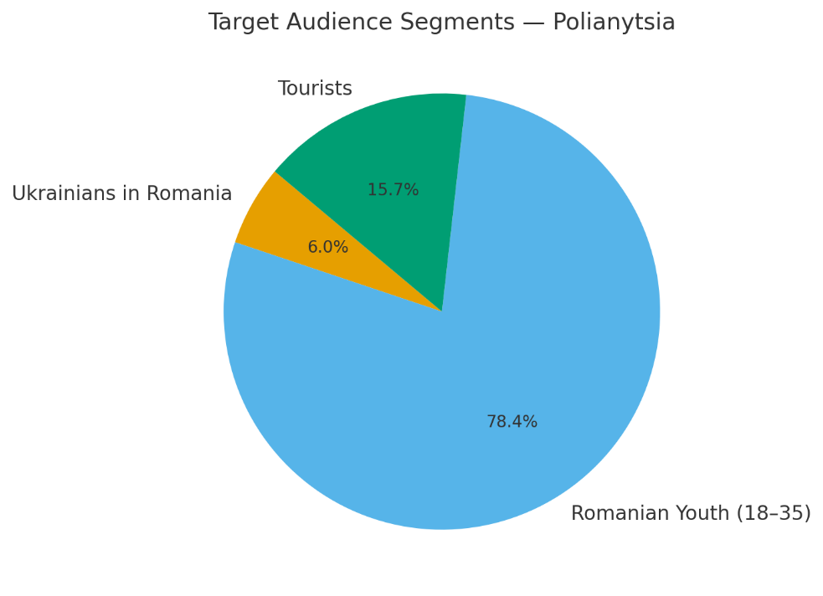
- about 0.5 million tourists → “authentic fashion with a story.”
Social context: 55% of Romanians support Ukraine; youth are particularly open to ethnic and creative projects.
Industry Overview
The global fashion market exceeds $1.7 trillion, driven by e-commerce growth, sustainability, and increasing demand for local and independent brands.

The Romanian fashion market was valued at approximately €6.9 billion in 2023 and is projected to reach €8.5 billion by 2028 (+3.3% CAGR). Online sales are expanding rapidly: total e-commerce reached €11.7 billion in 2024, with fashion accounting for $1.23 billion (+20 - 25% annual growth). Consumers are moving away from standardized mass-market retailers (Zara, H&M, Bershka) toward local and niche brands. Young people and tourists are particularly drawn to clothing with cultural identity and unique storytelling.

All collections will be imported directly from Ukrainian brands. By using EUR.1 certificates of origin, import duties are reduced to 0%. As an SRL registered for VAT, 4roomsUA will reclaim the 21% import VAT, keeping import costs limited to transport and customs clearance fees (approximately 3% of the purchase value). This ensures competitive pricing despite cross-border sourcing.

Ukrainian Brands Niche
Romania hosts ~190,000 Ukrainians under temporary protection, for whom culturally coded clothing is a way to preserve identity. For Romanian consumers, Ukrainian fashion is perceived as exotic and unique, creating additional value. In the ethnic and creative fashion segments, the niche is almost untapped, Ukrainian brands are barely represented in Romanian retail, either offline or online.

Brand Vision and Mission
4roomsUA envisions becoming a recognizable multi-brand destination for Ukrainian fashion in Romania and across the European Union. By bringing together diverse Ukrainian designers, from traditional artisans to modern streetwear innovators, the brand aspires to redefine cultural fashion as a sustainable, stylish, and emotionally resonant movement.

Its mission captures this spirit perfectly:
“4roomsUA is a symbol of cultural dialogue. We combine Ukrainian heritage with European fashion, creating clothing that makes the past relevant and the present meaningful.”

Through fashion, 4roomsUA not only introduces beautiful products but also celebrates identity, resilience, and creativity. The brand aims to stand as a cultural ambassador, strengthening the connection between Ukraine and Romania through design, collaboration, and shared values.

The legal structure as an SRL (Societate cu Răspundere Limitată) provides operational flexibility and tax efficiency. Initially registered as a microenterprise, 4roomsUA benefits from a low tax rate (1-3% of turnover) with an annual revenue cap of €250,000 (reduced to €100,000 from 2026).

The company’s first boutique will be located in the center of Târgu Mureș, occupying a space of approximately 50-70 square meters. Expansion is planned for Bucharest, Cluj, and Brașov, supported by a robust online presence through both its own e-commerce site and the eMAG marketplace. This hybrid approach ensures the brand’s accessibility to both local and international customers.

problem & solution

THE PROBLEM
- Ukrainian diaspora (~190,000 people): limited access to culturally relevant clothing; direct orders from Ukraine are costly and slow.

- Romanian youth(18 - 35): oversaturation with mass-market brands; limited alternatives in niche/local fashion.

- Tourists: demand for authentic, unique fashion souvenirs; Ukrainian and ethnic clothing absent in offline retail.

- Ukrainian brands: barriers to entering the Romanian market (customs, certification, distribution); no ready-made scaling platform.

OUR SOLUTION
- Curated offline boutique + online platform: Ukrainian brands (from ethnic to streetwear) brought together under one roof, available via store, website, and eMAG.

- “Two-in-one” assortment: affordable basics (Staff, Reload, Husll) for turnover + ethnic/capsule collections (Halychanka, Annabo, BartBag) for uniqueness.

- Simplified customer experience: local fitting, easy returns, 2-3 day delivery; average ticket €50-60 (cheaper than direct imports from Ukraine).

- Support for brands: 4roomsUA manages customs clearance, ensures duty-free entry via EUR.1 certificates, and reclaims import VAT. This guarantees cost-efficient and reliable delivery, allowing brands to focus on production while accessing a new EU market.

TARGET MARKET

MARKET SIZE & SEGMENTS
Market Overview
Romania’s fashion market presents an exciting landscape for niche and culturally driven concepts. Valued at €6.9 billion in 2023, the market is forecasted to grow to €8.5 billion by 2028, supported by steady consumer spending and a growing preference for independent brands. E-commerce continues to be a major force: in 2024, online sales reached €11.7 billion, with fashion alone accounting for over €1.23 billion, growing by 20-25% annually.

Customer Segments
4roomsUA’s audience is clearly defined and diverse, encompassing three main customer groups that together form a sustainable demand base:
1. Ukrainians living in Romania
Approximately 190,000 Ukrainians reside in Romania, many of whom maintain strong ties to their national heritage. With average monthly incomes between €800 and €1,000 and clothing budgets of €45-55, this group values both cultural identity and affordability. They represent a loyal, emotionally connected customer base for 4roomsUA.
2. Romanian youth aged 18-35
This segment, around 2.5 million potential buyers, is driven by curiosity, creativity, and a desire for self-expression. With average monthly incomes between €900 and €1,200, they spend roughly €50-60 on clothing. Their interest in ethnic and ethical fashion aligns perfectly with 4roomsUA’s positioning. Surveys indicate that 68% of young Romanians support international solidarity and are particularly receptive to Ukrainian initiatives.
3. Tourists and international visitors
An estimated 500,000 visitors each year seek authentic souvenirs and local fashion experiences. With an average spending range of €50-100 per purchase, they perceive Ukrainian fashion as exotic, artistic, and culturally rich — precisely the appeal that 4roomsUA embodies.

Social Context
- 55% of Romanians support Ukraine and blame Russia for the war.
- 190,000 Ukrainians reside in Romania under temporary protection.
- 40,000+ Ukrainian children are integrated in schools.
- 68% of young Romanians support international solidarity.
- 15-20% express concerns about jobs and infrastructure, but overall perception remains favorable.
Conclusion
- Average monthly clothing spend: €40-60 → aligns with 4roomsUA’s pricing.
- Favorable social attitudes toward Ukrainians → smoother brand acceptance.
- Ukrainian fashion niche is untapped.
- 4roomsUA’s import model (duty-free via EUR.1 + VAT reclaim) ensures competitive pricing while serving diaspora, youth, and tourists.

RISK ANALYSIS
Like all startups, 4roomsUA operates in an environment where both opportunities and challenges coexist. The following analysis identifies potential risks and outlines strategies for their mitigation.

Risk | Probability | Impact | Mitigation
Demand fluctuations | Medium | High | Seasonal collections, diversification (basics + capsules).
Price competition | High | Medium | Dual pricing strategy: basics for affordability, capsules for margin.
Logistics and supply disruptions | Medium | High | Use EUR.1 certificates for zero duties; consolidate shipments every 1-2 months; VAT registration for refunds; licensed brokers to minimize delays.
Legal/tax changes | Medium | Medium | SRL compliance, accounting support, diversify sourcing.
Reputation/social perception | Low-Medium | Medium | Focus on creativity and fashion, not humanitarian narrative.
Currency fluctuations | Medium | Medium | Contracts in EUR, hedging, fixed supplier agreements.
Operational risks | Medium | Medium | Staff training, manuals, outsourced accounting/legal services.
Market entry risks | Medium | High | Strong marketing, influencer collaborations, cultural events.

Most risks are manageable with proactive planning. Logistics and price competition are the main vulnerabilities, but 4roomsUA’s structured import strategy (EUR.1 + VAT reclaim + shipment consolidation) significantly reduces exposure. Social perception remains favorable, limiting reputational risks.

SWOT ANALYSIS
Strengths | Weaknesses
First store in Romania specializing in Ukrainian fashion. | Dependence on cross-border logistics from Ukraine.
Unique positioning: mix of ethnic heritage + modern fashion. | New brand in Romania — low initial awareness.
Loyal diaspora (~190,000 Ukrainians in Romania). | Limited resources compared to international chains.
Dual channel model: offline boutique + online (website + eMAG). | Potentially higher prices vs. mass-market.
Efficient import scheme: 0% duties with EUR.1, VAT reclaim.

Opportunities | Threats
Romanian fashion market growth (+3.3% CAGR). | Price competition from mass-market (Zara, H&M, Bershka).
Rising demand for niche, local, and cultural fashion. | Aggressive discounting from outlets.
Positive perception of Ukrainians in Romania (55% support, youth 68% solidarity). | Economic slowdown reducing consumer spending.
Expansion to Bucharest, Cluj, Brașov; later EU markets. | Changes in taxation (VAT increase, microenterprise rules).
Popularity of slow fashion and sustainability in Europe. | Risk of “refugee fatigue” or shifting public sentiment.

Key Insights from SWOT:
- Strength + Opportunity → Unique positioning + positive market sentiment = first-mover advantage.
- Weakness + Threat → Logistics and pricing are risks, but 4roomsUA’s import scheme (0% duty + VAT reclaim) reduces exposure.
- Strategic focus → Build strong brand awareness quickly (youth + diaspora + tourists) and highlight cultural identity to stand apart from price competition.

4roomsUA’s first-mover advantage, combining authentic cultural fashion with a favorable market sentiment, provides a solid foundation for success. By prioritizing brand awareness, storytelling, and community engagement, the company can differentiate itself beyond pricing and secure a meaningful presence in Romania’s fashion industry.

COMPETITION

CURRENT ALTERNATIVES TARGET BUYERS ARE USING
In Romania, and specifically in Târgu Mureș, fashion buyers currently rely on the following main channels:
- International chains (mass market): Zara, H&M, Bershka, Pull&Bear, New Yorker.
Strengths: strong brand recognition, wide assortment, affordable prices, convenient mall locations.
Weaknesses: standardized collections, lack of uniqueness or ethnic motifs, low cultural value.
Why it’s an alternative: young people shop here for affordable basics.
- Outlets and discount stores: Stopbutik Outlet, New Yorker discount lines.
Strengths: aggressive pricing, attractive to price-sensitive customers.
Weaknesses: limited selection, outdated collections, weaker brand image.
Why it’s an alternative: customers save money but compromise on quality and style.
- Local boutiques and multi-brand stores: Boutique For You, Flamour, House, Chic, Sense.
Strengths: understanding of local tastes, personalized service, niche collections.
Weaknesses: limited assortment, small marketing budgets, lack of scalability.
Why it’s an alternative: appeals to clients who value individuality and boutique service.
- Online platforms: Zalando, AboutYou, ASOS, eMAG (fashion segment smaller).
Strengths: wide assortment, international reach, convenient online shopping.
Weaknesses: higher prices, long delivery times (especially outside Romania), complex returns.
Why it’s an alternative: youth and tourists order trendy clothing online, but without cultural identity.

Summary of Competitive Landscape
- Competition is diverse: mass market covers the mainstream, outlets serve price-sensitive buyers, and boutiques attract niche audiences.
- The Ukrainian fashion niche is untapped: no competitor systematically offers Ukrainian brands, ethnic styles, or culturally coded fashion.
- 4roomsUA’s positioning:
  - Differentiation through cultural identity and storytelling.
  - Dual pricing strategy: affordable basics + premium capsules.
  - Balance of assortment, service, and cultural value.

OUR COMPETITIVE ADVANTAGES
Product and Assortment
The concept revolves around an exclusive selection of Ukrainian brands that are not available in Romanian retail, offering customers a unique and authentic experience. The assortment follows a dual-segment strategy: accessible, everyday basics from brands such as Staff, Reload, and Husll, complemented by premium capsule collections from niche designers like Halychanka, Annabo, and BartBag. Some collections are released in numbered limited editions, reinforcing their exclusivity and collectible appeal. Each product carries its own story through detailed labels that explain the cultural context, from the meaning of traditional ornaments to the heritage of each brand. Altogether, the assortment blends ethnic heritage, streetwear, and contemporary casual fashion into a coherent and modern offering.

Store and Interior
The physical store is designed as a cultural hub, merging aesthetics with meaning. Natural materials, soft lighting, and Ukrainian ornaments create a warm, authentic space where each visual element reflects the brand’s identity. A dedicated “Heritage Corner” presents the symbolism behind Ukrainian motifs and patterns, turning the store visit into a cultural discovery. The ambiance is enhanced by background music featuring Ukrainian indie, jazz, and folk sounds in contemporary arrangements, immersing visitors in a modern yet soulful atmosphere.

Staff and Service
The team functions as cultural ambassadors, connecting customers with the deeper story behind every product. Their uniforms maintain a modern look, subtly enriched with ethnic details such as embroidered collars or ornamental sleeves. Staff members are trained to share insights about the origins and symbolism of each brand and collection, transforming sales into meaningful storytelling. Customers benefit from personalized service through in-store and online “look curation,” helping them build cohesive outfits that match their style. A quality guarantee ensures a simple and transparent return or exchange process within 14 days, free from unnecessary bureaucracy.

Brand and Marketing
The brand’s identity is defined by authenticity and cultural depth, expressed through a modern logo and signage inspired by traditional motifs. Marketing focuses on storytelling and collaboration: partnerships with Romanian youth influencers and Ukrainian creators highlight the cross-cultural exchange at the brand’s core. The brand maintains a strong festival presence, with pop-ups at major cultural events such as TIFF Cluj and the Sighișoara Medieval Festival. Social media content emphasizes the human and symbolic stories behind the products, while multilingual communication, in Romanian, Ukrainian, and English ensures inclusivity and accessibility.
Logistics and Accessibility
An optimized import model allows for competitive pricing through 0% customs duties (EUR.1 certificates) and VAT reclaim. This system ensures that high-quality Ukrainian products remain affordable within the Romanian market. Delivery times are efficient, with orders arriving in 2-3 days across Romania and within one week across the EU.

Social Mission
Beyond commerce, the brand stands for solidarity and cultural preservation. Every purchase contributes directly to the growth of Ukraine’s fashion industry, supporting designers and craftspeople in rebuilding and developing their businesses. Occasionally, charity capsule collections are launched, with a portion of the profits donated to social and humanitarian initiatives, reinforcing the brand’s commitment to meaningful impact through fashion.

PRODUCT OR SERVICE OFFERINGS

PRODUCT OR SERVICE
Product Overview
4roomsUA is a multi-brand boutique of Ukrainian fashion in Romania, combining ethnic collections, contemporary casual, and streetwear. The assortment is built through direct contracts with Ukrainian manufacturers and a unique import scheme (0% duties with EUR.1 + VAT reclaim). This ensures competitive pricing while preserving exclusivity and cultural value.

Core Product Categories
- Basic Streetwear & Casual
  - Suppliers: Staff, Husll, Reload, O.TAJE.
  - Products: hoodies, sweatshirts, T-shirts, tracksuits, jackets, trousers.
  - Benefit: affordable pricing, high turnover, foundation for everyday demand.
- Image Streetwear Capsules
  - Suppliers: Good Boys Club, TUR WEAR, Streetwear.com.ua.
  - Products: hoodies and T-shirts with prints and patches, cargo pants, symbolic accessories.
  - Benefit: creates a unique brand image, attracts youth, generates PR buzz.
- Ethnic Line (Cultural DNA)
  - Suppliers: Halychanka, Annabo Fashion.
  - Products: embroidered shirts, clothing with ornaments, linen and cotton items.
  - Benefit: brand’s cultural code, tourist appeal, seasonal/holiday sales.
- Accessories & Premium Items
  - Suppliers: BartBag, MFS.
  - Products: leather bags, backpacks, belts, cardholders, jewelry.
  - Benefit: increases average basket size, gift purchases, premium brand perception.
- Women’s Fashion Line
  - Suppliers: 25 Union, O.TAJE.
  - Products: designer dresses, office and evening wear, casual knitwear.
  - Benefit: closes the women’s fashion segment, adds variety to the assortment.

Unique Value Proposition
The brand’s strength lies in its exclusivity, bringing Ukrainian fashion labels that are entirely absent from Romanian retail and offering customers something truly original. Its approach balances affordability and prestige, combining accessible everyday basics with premium capsule collections that add a distinctive, high-end edge. Each collection embodies cultural authenticity, showcasing ethnic inspired designs accompanied by storytelling on labels that reveal the story behind the garment its symbols, origins, and craftsmanship. The brand delivers a complete shopping experience, enabling customers to curate full looks that integrate both clothing and accessories, harmonizing tradition and contemporary style.

Innovation and Technology
Innovation drives both the business model and the customer journey. The import model leverages EUR.1 certification to achieve 0% customs duties and enable VAT reclaim, resulting in cost savings of up to 12%. An integrated inventory system synchronizes offline and online sales channels through WooCommerce and eMAG, ensuring real-time stock visibility and seamless customer service. Storytelling extends into the digital realm through QR codes placed on garments, linking directly to the history of each brand and the cultural meaning of its ornaments. The brand also employs a capsule drop model, releasing limited collections that create a sense of rarity and encourage repeat engagement.

Sustainability and Social Responsibility
At its core, the brand follows the principles of slow fashion, focusing on limited production runs, premium fabrics, and long lasting quality over mass quantity. Sustainability is reflected in the use of eco-friendly materials such as linen, cotton, and recycled textiles, featured prominently in collections by designers like Annabo and O.TAJE. The brand’s social mission is equally important: every purchase supports Ukrainian brands and artisans, while special charity capsule collections allocate part of their profits to social and community projects. Additionally, consolidated import logistics help reduce transportation frequency, minimizing the carbon footprint and aligning the business with responsible, ethical practices.

Final Product Positioning:
4roomsUA is a fashion + cultural hub, offering affordable basics, exclusive ethnic & image capsules, and premium accessories. We do not compete with Zara or H&M in the mass market; instead, we deliver a unique assortment, cultural experience, and competitive pricing enabled by optimized import logistics.

marketing

MARKETING PLAN
4roomsUA’s marketing strategy blends cultural authenticity with digital creativity. Its goal is not only to drive sales but to build a community around shared values of identity, art, and sustainability.
The overall goal is to position 4roomsUA as Romania’s first and leading Ukrainian fashion brand while nurturing trust, expanding both online and offline visibility, and establishing the brand as a true cultural bridge between Ukraine and Romania.

Marketing Objectives
The marketing efforts are structured around four primary goals:
- Awareness. Position 4roomsUA as Romania’s first and leading Ukrainian fashion brand.
- Trust. Leverage connections within the Ukrainian community to build immediate credibility.
- Sales. Increase both online and offline traffic through engaging storytelling and smart pricing.
- Reputation. Establish the brand as a cultural bridge between Ukraine and Romania.

Target Audience & Communication Channels
- Ukrainian diaspora (~190,000 people)
To achieve this, the marketing team focuses on three interconnected audiences. The Ukrainian diaspora, numbering around 190,000 people, represents a core group that values authenticity and cultural belonging. Communication with this segment is developed through Facebook and Telegram communities, collaborations with NGOs, and Ukrainian cultural centers and schools. Word-of-mouth and trust within this community are powerful tools that ensure rapid organic growth.
- Romanian youth (18-35 years)
The Romanian youth segment, aged between 18 and 35, is drawn to creative, ethical, and meaningful fashion. Here, 4roomsUA uses Instagram, TikTok, and influencer partnerships to communicate visually through Reels, lookbooks, and storytelling about designers and brands. The novelty of Ukrainian fashion and its emotional resonance are key drivers of engagement within this group.
- Tourists
Finally, the tourist audience, particularly visitors seeking authentic and artistic souvenirs, is reached through platforms like TripAdvisor, Google Maps, and Instagram geotags. By positioning the boutique as a “must-visit cultural spot,” supported by limited souvenir-focused capsule collections, the brand appeals to those looking for meaningful purchases connected to local culture.

Promotion Tools
Promotion activities combine several complementary approaches:
- Social Media: storytelling through Instagram, TikTok, and Facebook fuels awareness and emotional connection;
- Public relations and events: including participation in major cultural festivals such as TIFF Cluj and the Sighișoara Medieval Festival, reinforce brand visibility;
- Influencer Marketing: with both Romanian and Ukrainian creators expand reach across communities;
- Community Marketing: co-branded initiatives with Ukrainian associations and support centers;
- Digital Marketplace: digital campaigns on platforms like eMAG and Google Ads further drive targeted online sales.

Loyalty and Retention
- 4roomsUA Friends Club: loyalty card (points, discounts, access to limited editions).
- Referral Program: “bring a friend — get a discount.”
- Exclusive Access: early access to capsules for repeat customers.
- Content-driven retention: newsletters (email/Telegram) about new brands, stories, and promotions.
Customer retention is supported through loyalty mechanisms such as the 4roomsUA Friends Club, offering exclusive discounts and access to limited editions, and a referral program that rewards community engagement. Returning customers also enjoy early access to new capsule collections, while newsletters on email and Telegram provide updates on new arrivals, stories, and upcoming events.

Budget and Key Performance Indicators:
- Digital (SMM + paid ads): €200-300/month.
- Events & Festivals: €1,000-2,000/year.
- Influencers: €100-300 per collaboration.
- Community Marketing: low-cost, driven by partnerships and personal networks.
KPI (Year 1):
- 5,000-7,000 followers on Instagram/TikTok.
- Social media → sales conversion: 3-5%.
- Repeat purchases: 25-30% by end of year one.

The marketing budget remains lean and efficient, focusing on digital performance and community partnerships. Social media campaigns are expected to cost €200-300 per month, while event participation and influencer collaborations represent modest, strategic investments. The company’s first-year key performance indicators include achieving 5,000-7,000 followers on social media, converting 3-5% of that audience into sales, and reaching a 25-30% repeat purchase rate by the end of the first year.
By combining trusted positioning within the Ukrainian diaspora, trend-driven digital engagement with Romanian youth, and the authenticity valued by tourists, 4roomsUA builds a marketing ecosystem that ensures sustainable brand awareness, community loyalty, and scalable sales growth.

ORGANIZATION AND MANAGEMENT
Legal Form and Taxation
The company is registered as an SRL (Societate cu Răspundere Limitată), the Romanian equivalent of an LLC. It operates under the microenterprise regime (1 -3% turnover tax). Since the business model is based on importing clothing and accessories from Ukraine, the company is VAT registered (21%), allowing for efficient cost recovery and fiscal transparency.

Supplies are imported directly from Ukrainian manufacturers under EUR.1 certificates of origin, ensuring 0% customs duties. Customs clearance is handled by a licensed Romanian broker, while logistics are consolidated every one to two months to optimize transport costs. The import VAT of 21% is paid upfront and later reclaimed as input VAT, resulting in an efficient, cost-effective supply chain.

Import scheme:
- Supplies are delivered directly from Ukrainian manufacturers;
- Customs clearance is handled by a licensed broker in Romania;
- With a valid EUR.1 certificate of origin, goods are exempt from customs duties (0%);
- Import VAT (21%) is paid and reclaimed as input VAT;
- Logistics are consolidated (every 1 - 2 months) to optimize costs.

Team
The core team consists of four experienced professionals who have previously collaborated on social initiatives supporting Ukrainian refugees in Romania. Their multilingual backgrounds, including fluency in Ukrainian, Russian, Romanian, English, and French, combined with expertise in management, sales, marketing, and administration, form a solid foundation for the brand’s success. The team’s digital literacy and strong connections within both the Ukrainian and Romanian communities further enhance their ability to grow the business rapidly.
Key team strengths:
- Multilingual skills: Ukrainian, Russian, Romanian, English, French.
- Experience: business management, sales, marketing, administration.
- Adaptability: digital literacy, market knowledge, and quick response to change.

Roles and Responsibilities
Roles are clearly defined: one co-founder oversees management and procurement, another leads store operations and customer relations, a third handles online sales and customer support, while the fourth manages marketing and communications. Accounting is outsourced to maintain lean operations and professional compliance.
- Management and purchasing: Director (1 team member).
- Store operations and customer service: 1 team member.
- Online sales and phone support: 1 team member.
- Marketing and promotion: 1 team member.
- Accounting: outsourced (service agreement, not a team member).

This team’s strength lies in its cohesion, proven project experience, and shared mission. Their established trust network within the Ukrainian community, combined with a deep understanding of Romanian consumer culture, creates an agile organization capable of adapting quickly and scaling sustainably. With its mix of creativity, structure, and purpose, 4roomsUA’s team represents the ideal foundation for long-term success in both the retail and cultural sectors.

timeline & METRICS

In the next sections you can describe your next activities, milestones and metrics you are planning to achieve.

TIMELINE
ACTIVITY | DESCRIPTION | COMPLETION DATE
Company registration | Register SRL, VAT registration | Month 1
Signing contracts | First agreements with Ukrainian brands | Month 2
First shipment | Customs clearance + delivery of first collection | Month 2-3
Store opening | Rent, renovation, equipment, launch of offline boutique | Month 3
Website & social media | WordPress e-shop + Instagram/TikTok/Facebook launch | Month 3
eMAG marketplace entry | Onboarding to eMAG platform | Month 6
First capsule collection | Joint release with one of the brands | Month 9
Assortment expansion | Adding accessories and eco-friendly brands | Month 12
Second store | Opening in Bucharest or Cluj | Month 18-24
Online EU sales | Launching cross-border online sales | Month 24

MILESTONES
MILESTONE | DESCRIPTION | COMPLETION DATE
Break-even point | 325 sales/month | Month 6
400 clients/month | Stable customer flow achieved | Month 12
First 10,000 followers | Growth on Instagram/TikTok | Month 12
Second location | Store in Bucharest or Cluj | Month 24-36
Online EU expansion | Launch of international online sales | Month 24

KEY PERFORMANCE METRICS
ACTIVITY | DESCRIPTION | KEY METRIC
Customers | Number of offline + online buyers | 325 → 500+/month
Average ticket | Average purchase value | €50-60
Revenue | Business turnover | €10k → €30k+/month
Online sales | Share of e-commerce in total turnover | 30% by Month 24
Repeat purchases | Loyal customer share | 40% after 12 months
Marketing (social media) | Instagram/TikTok/Facebook followers | 10k+ in 12 months
Brands in portfolio | Partnered Ukrainian brands | 8-12 by Year 1

TIMELINE & METRICS

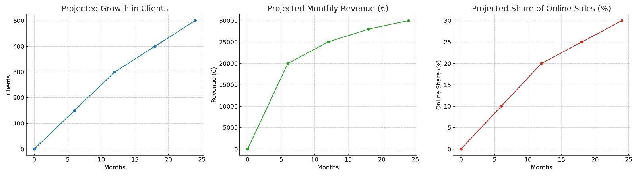

FINANCIAL FORECASTS

KEY ASSUMPTIONS
year | income | costs | result
2026 | 240 000,00 | 220 681,60 | 19 318,40
2027 | 302 400,00 | 272 672,06 | 29 727,94
2028 | 380 160,00 | 343 722,81 | 36 437,19

The link for the financial plan is: https://docs.google.com/spreadsheets/d/1Ba4ejrpDYN26Ofbgn-Qzig5wm16-x--4/edit?gid=1453213130#gid=1453213130

Summary of Financial Growth and Assumptions

Revenue Growth:
4roomsUA projects steady and sustainable revenue growth, increasing from €240,000 in 2026 to €302,400 in 2027 and €380,160 in 2028. This growth is supported by the expansion of the product assortment, strong online sales via eMAG and the brand’s website, and the opening of a second store in Bucharest or Cluj. The average annual growth rate of around 25 - 30% reflects the scalability of the business model and the increasing visibility of Ukrainian brands in Romania.

Cost Management:
The company maintains a disciplined approach to cost control through its optimized import model (0% customs duties via EUR.1 certificates and VAT reclaim), efficient logistics consolidation every 1 - 2 months, and lean staffing structure. Fixed operational expenses remain moderate, while variable costs are tightly linked to sales volume, ensuring flexibility and financial resilience. Continuous supplier negotiations and in-house marketing also help preserve healthy margins.
Profitability:
Net profit is forecasted to grow from €19,318 in 2026 to €36,437 in 2028, resulting in an average profitability of approximately 9.3% over the first three years. The dual-segment pricing strategy, affordable basics for consistent cash flow and premium capsules for higher margins, underpins profitability while supporting brand differentiation.

Break-Even Point:
The company is expected to reach its break-even point within the first six months of operation, corresponding to roughly 325 sales per month. This early break-even is achievable thanks to the balanced assortment, favorable import conditions, and effective marketing targeting both the Ukrainian diaspora and Romanian youth segments.

Long-Term Outlook:
Beyond 2028, 4roomsUA plans to scale both geographically and digitally, expanding to additional Romanian cities (such as Brașov) and growing EU-wide e-commerce sales. Franchising opportunities and the addition of new product categories: footwear, home decor, and children’s clothing, will further diversify revenue streams and strengthen market presence. The brand aims to establish itself as the primary gateway for Ukrainian designers into the EU market.

Financial Outlook Summary:
4roomsUA demonstrates a clear path to profitability, early return on investment (9 - 14 months), and consistent revenue growth. With low operating risks, strong market positioning, and cultural relevance, the project combines financial viability with social and creative impact. The financial assumptions are realistic, grounded in conservative sales forecasts and efficient cost structures, providing a solid foundation for long-term investor confidence and sustainable expansion.

OPTIONAL - ADDITIONAL MATERIAL
The additional material provided can include:
- Business Model Canvas - https://www.strategyzer.com/library/the-business-model-canvas
- Empathy Map - https://online.visual-paradigm.com/diagrams/features/empathy-map-template/
- Value Proposition Canvas - https://www.strategyzer.com/library/the-value-proposition-canvas
- Other type of frameworks you used to develop your startup and plans

The documents you chose to provide are optional.

